LINKS TO RESOURCES: MEDIA CLIPS and photos for ISJ

Roshan Galvaan :
Key note address http://www.amsterdamuas.com/urban-vitality/shared-content/events/conferences/2019/08/ose-2019.html
SII Book: www.news.uct.ac.za/article/-2018-12-04-book-documents-sii-schools-empowerment-strategy
OBCD - https://vula.uct.ac.za/access/content/group/9c29ba04-b1ee-49b9-8c85-9a468b556ce2/OBCDF/pages/iex.html

Madagascar Curriculum project: Training of OTs

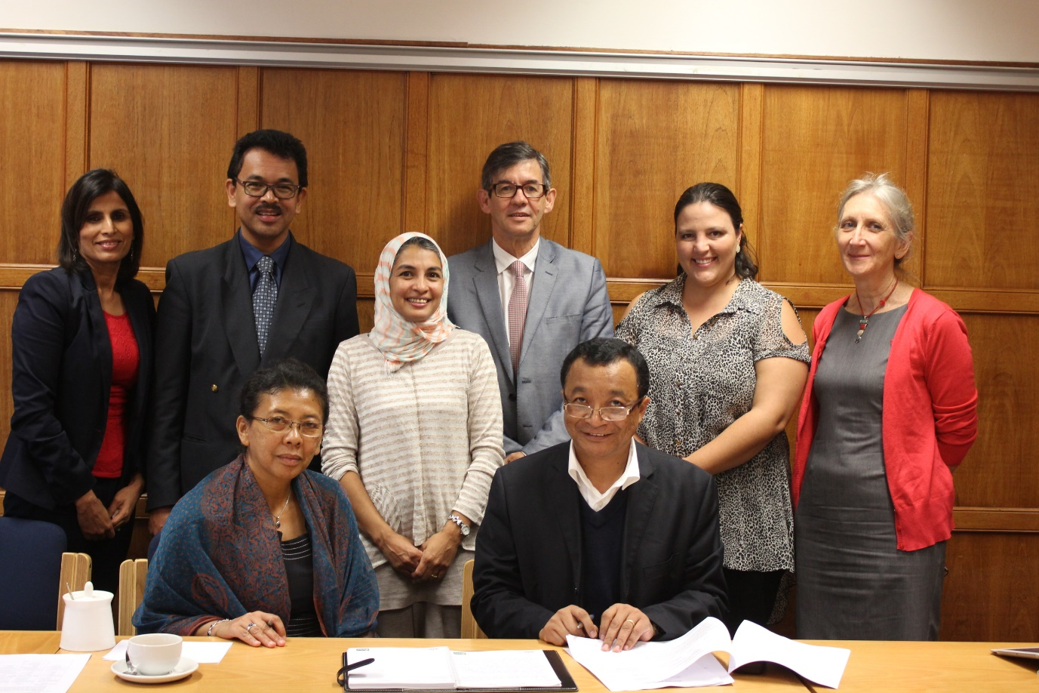

Harsha Kathard
Participating in curriculum discussion: Stanford: South African Summit trailer Here is the Here is the Youtube link.
Establishing of Health sciences Education Department http://www.health.uct.ac.za/fhs/departments/health-sciences-education
Book launch : Promoting inclusive practices http://www.health.uct.ac.za/sites/default/files/image_tool/images/116/Newsletters/FHS-News-2nd%20Quarter-2015.pdfr and
EPIC PROJECT http://www.dhrs.uct.ac.za/dhrs/divisions/csd/epic/intro

Theresa Lorenzo
Disability studies programme http://www.dhrs.uct.ac.za/dhrs/divisions/disability/staff/tlorenzo
Rehabilitation care worker programme
Disability Catalysts – upload
Alumni/Inclusion advocates
Marlene Le Roux https://www.artscape.co.za/podcasts/meet-marlene-le-roux/
Thomas Ongolo: https://za.linkedin.com/in/thomas-ongolo-9150503b
Christine Peta http://www.health.uct.ac.za/news/christina-peta-obtains-phd-disability-studies-first-zimbabwe

Disability Catalyst
https://vula.uct.ac.za/access/content/group/9c29ba04-b1ee-49b9-8c85-9a468b556ce2/Disability%20Catalyst%20Africa%20Series%202014/index.html

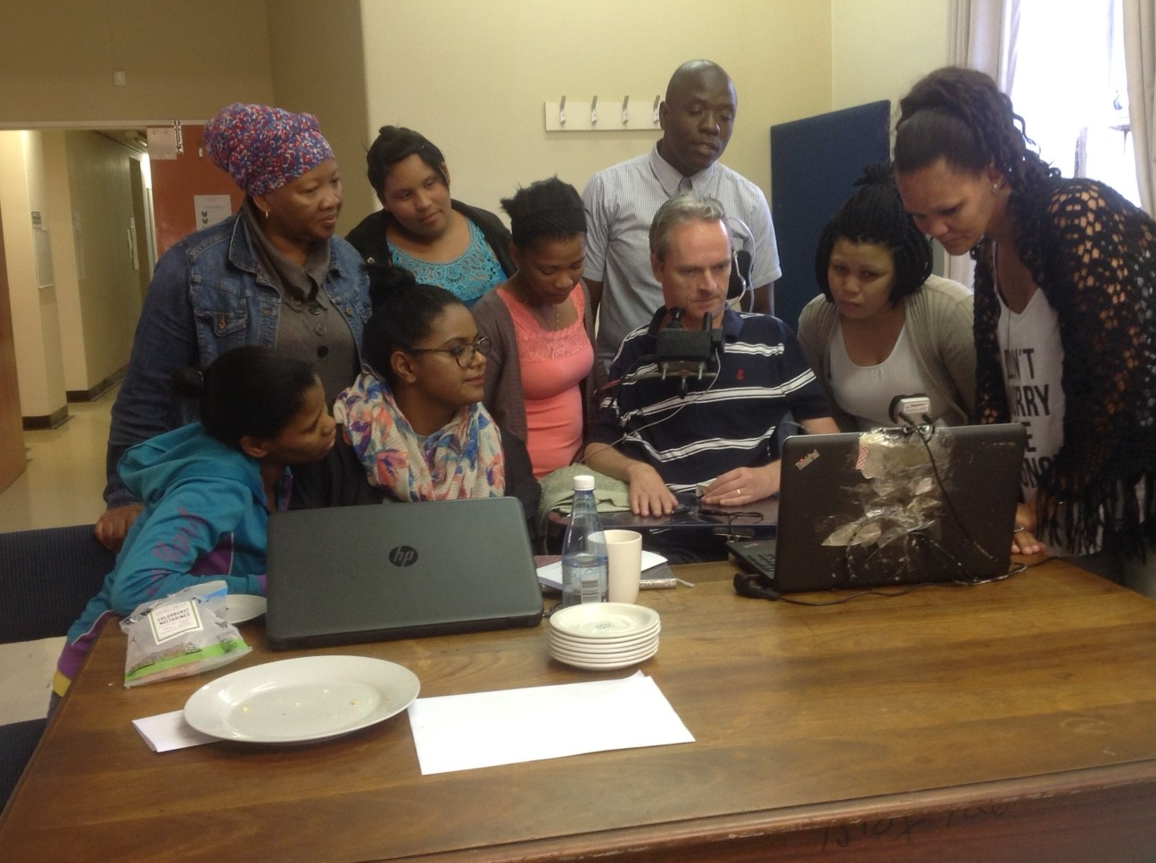
VIC McKinney PhD graduate UCT Disability Studies Vic a research affiliate training research team' including six community disability practitioners in participatory methods for sports for work project, and how he uses a computer as a quadriplegic.
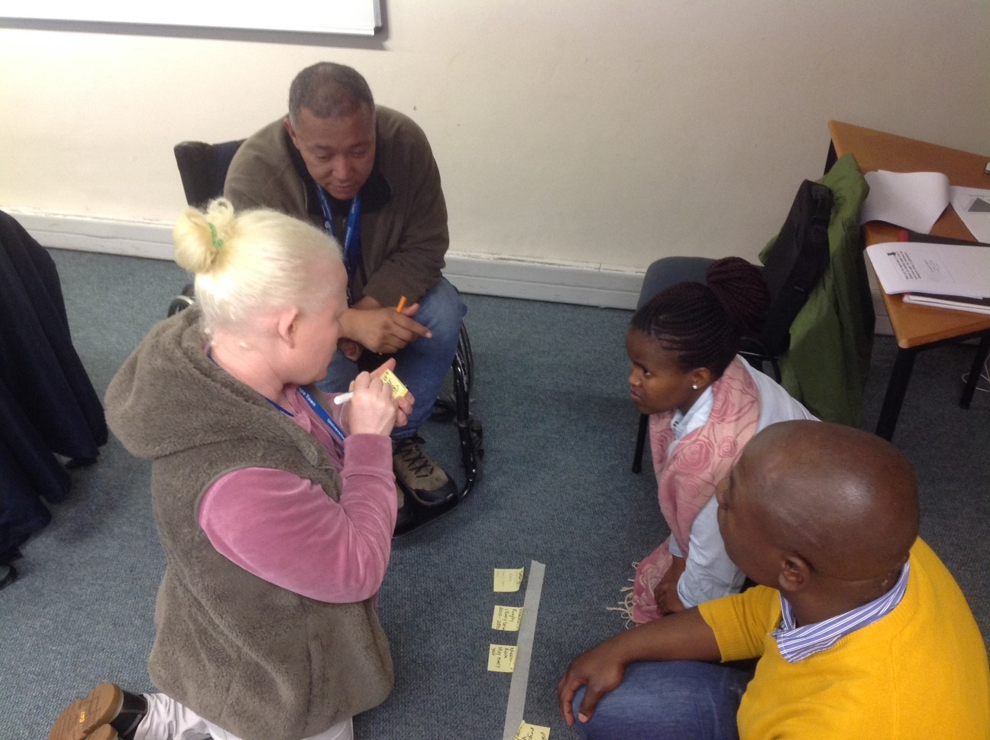
Postgrad students learning participatory methods for monitoring disability inclusion
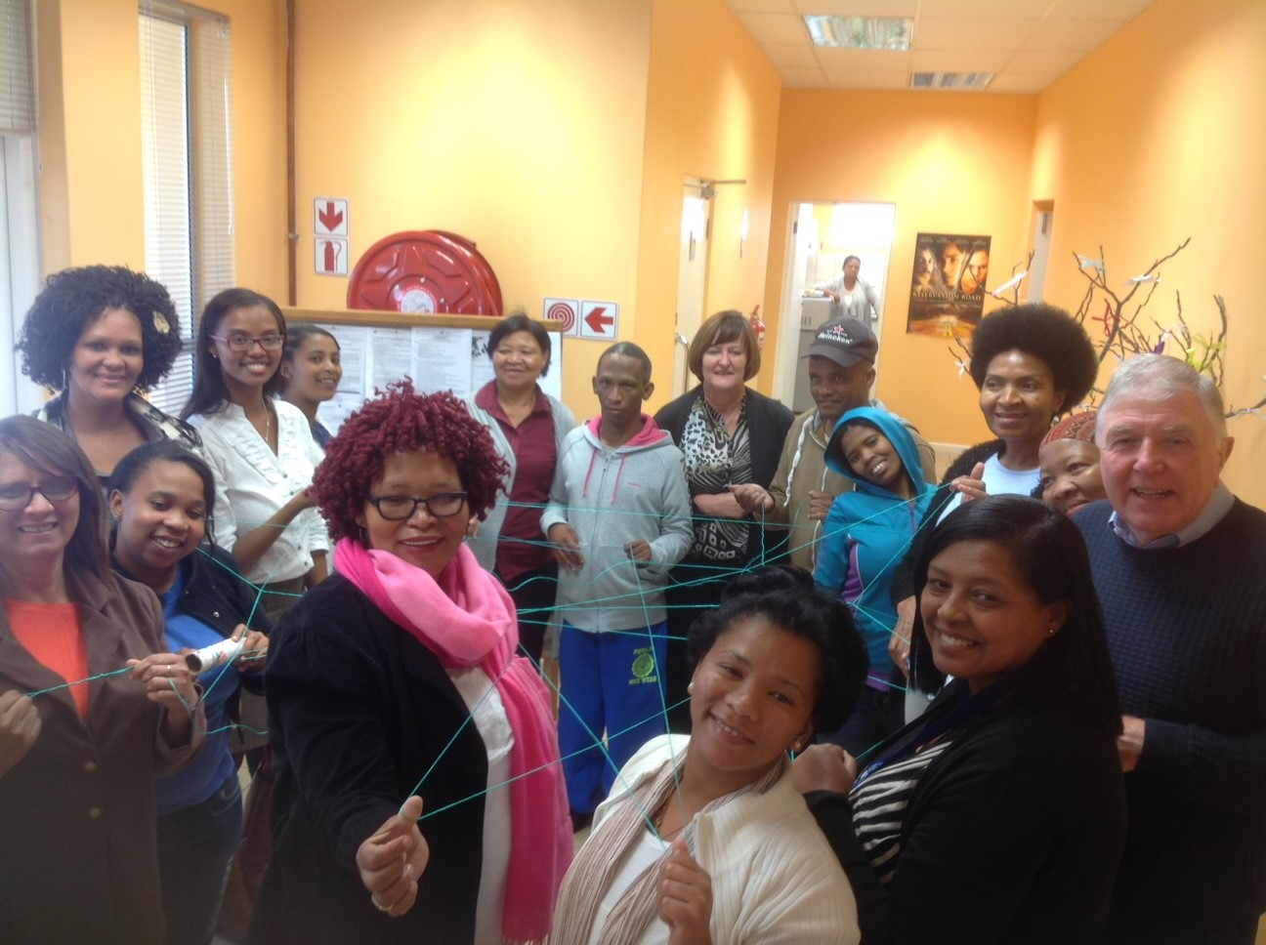
Workshop with rural farming communities on disability inclusion in sports and livelihoods development by forming support networks for action learning with service providers and disabled people's organsiations

