2020 INTERNATIONAL WOMEN DAY REPORT
HELD AT SERENA HOTEL IN DAR ES SALAAM DATE 6 March 2020

The Embassy of the Kingdom of Netherland in collaboration with Voice Global organized the International Women Day to celebrate UNSUNG SHEROES ,the women who are change makers and whose successful activities have accelerated gender equality in our society .The event took place on Friday 6 March ,2020 from 08:30am to 11:30am at Serena Hotel .

FUWAVITA as one of Voice Global member invited to attend this great event. Our FUWAVITA Director Ms Aneth Gerana ,she joined with other women in the Penal Discussion to represent women with disabilities issue’s of concern. She also awarded as an African Feistiest Woman who have accelerated gender equality in the society especial to women and girls with disabilities.

We thank Voice Global for always including women with disability in their program.
PICTURES

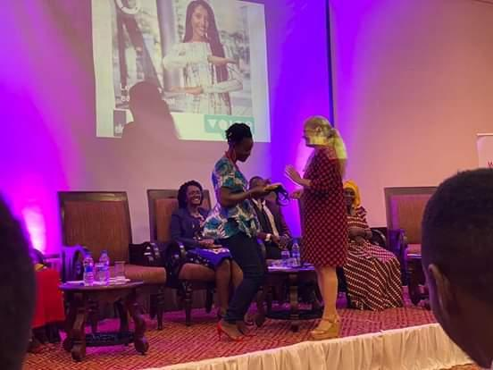
The above Picture show Ms Aneth Gerana (Deaf) receiving AWARD during 2020 International Women Day

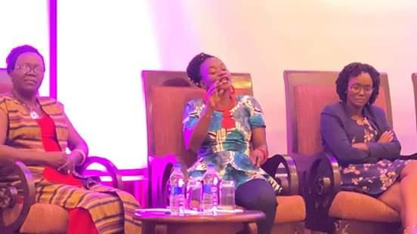

The above picture show Ms Aneth Gerana (Deaf) represent women with disabilities during panel Discussion

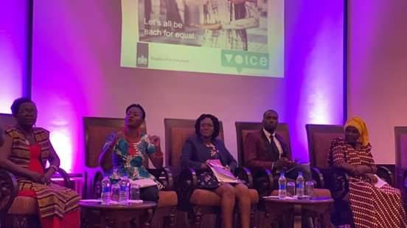

ROTARY CLUB OF PUGU INTERNATIONAL WOMEN DAY AWARD DATE 8/3/2020
HELD AT ONOMO HOTEL IN DAR ES SALAAM

Again we FUWAVITA thank Rotary Club of Pugu for including women with disability during the 2020 International Women day and awarded our Director Ms Aneth Gerana (Deaf) an award of recognition toward her effort of empowering women and girls with disabilities in Tanzania.

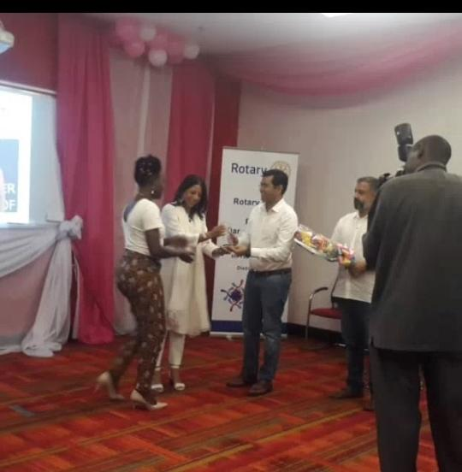

The above picture show Ms Aneth Gerana (Deaf) receive her Award from Rotary Club of Pugu

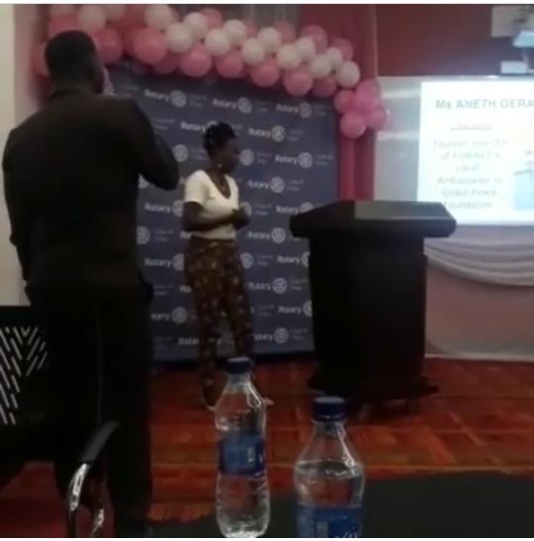
The above picture show Ms Aneth Gerana (deaf) presenting on how she empowered 500 women with disabilities by using her Sign language Interpreter during Rotary Club Of Pugu International Women Day Award.

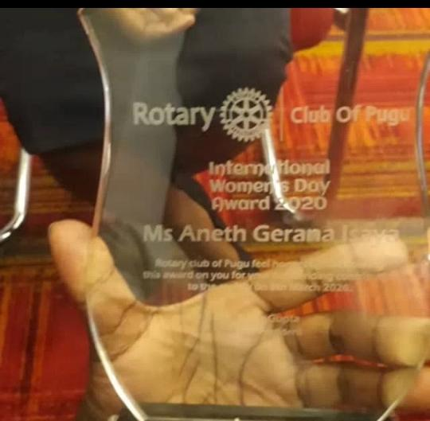
https://inclusivenews.com.ng/2020/03/19/intl-womens-day-deaf-woman-inspires-africans-disabilities-receives-two-awards/

https://inclusivenews.com.ng/2020/03/02/deaf-woman-becomes-role-model-in-leadership-in-africa-wins-post-for-public-relation-officer/

​ https://www.facebook.com/FUWAVITA/

Instagram:​ https://www.instagram.com/fuwavitadeaf/

​

http://www.alldeaf.com/threads/the-first-udsm-deaf-and-dumb-student.38818/

​ https://www.globalpeace.org/blog/empowering-women-disabilities-aneths-story

https://youtu.be/FTgkFnBmmLE

https://youtu.be/nYXyFM1HLJ4

https://youtu.be/QhMJz0mhxlM

https://inclusivenews.com.ng/2019/12/02/many-companies-and-stakeholders-refuse-to-hire-me-due-to-my-deafness-aneth-isaya/

