Zero Project receives 475 nominations from 93 countries

The Zero Project has completed the nomination process for Innovative Practices and Policies in the field of Employment and ICT. It has received a record of 475 nominations from a total of 93 countries.

Vienna 20th July 2020: The Zero Project researches leading innovations supporting the implementation of the UN Convention on the Rights of Persons with Disabilities (CRPD) around the world. Within a four-year-cycle, the focus of 2020/21 is on Employment and ICT.
The nomination process started in May 2020 and the Call for Nominations closed on 5th July 2020. For the first time, the Zero Project used 4 categories: Nominations from civil society, from the public sector, from the business sector all on inclusive employment, and in addition to that a fourth category on accessible and inclusive technology (ICT).
The Zero Project received a record of 475 nominations from 93 countries, beating the previous best of 469 nominations in 2019. The nominations were nominated in 6 different languages and cover a wide variety of topics and solutions, including inclusive employment strategies of companies, IT- based job platforms, supported employment services, social business and entrepreneurship, models on vocational support in higher education, inclusion consultancy services/trainings focusing on employers and many more.

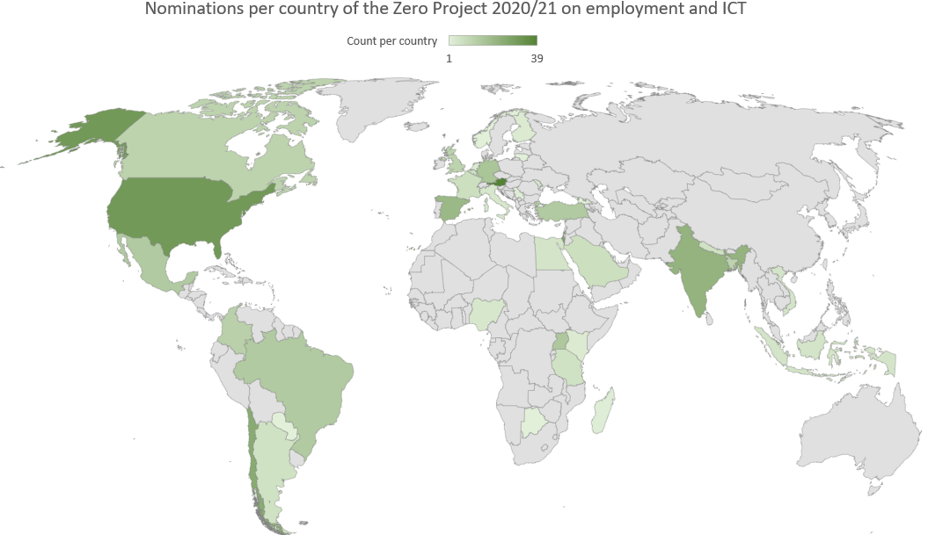

Nominations by world regions and countries
Analyzed by world regions, 166 originate in Europe, 115 in the Asia & Pacific region, 74 in Latin America and the Caribbean, 58 from Africa, 56 from North America and 6 from Australia & Oceania. Due to the Zero Project-partnership with Fundación Descúbreme from Chile, the region with the highest growth rate is Latin America.
Countries where the most Innovative Practices were nominated:
1. | Austria | 39
2. | United States | 31
3. | Israel | 28
4. | Chile | 25
5. | India | 22
6. | Spain | 20
7. | Germany | 16
8. | Uganda | 15
9. | Brazil | 14
10. | Mexico | 14
11. | Turkey | 14

Among those countries whose number of nominations have increased significantly are Argentina, Colombia, France, Indonesia, Kenya, Mexico, Moldova, the Philippines, Saudi Arabia, Tanzania, Turkey, Uganda and the United Arab Emirates.
Countries, where we received nominations from for the first time: Chad, DR Congo, Myanmar and Trinidad & Tobago.
Nominations by categories: civil society in the lead
247 nominations on employment solutions originate from civil society, 91 from the business sector and 33 from the public sector. 104 cover the topic of innovative ICT solutions.

Next steps in the Zero Project selection process
The process of peer-review, shortlist, voting and selection of this year´s Innovative Practices and Policies is currently in progress. As a next step, the Shortlist will be announced by the end of August at the latest.
The final selection of Awardees will be published in the Zero Project Report 2021 on Employment and ICT and will present at Zero Project Conference in February 2021 at the United Nations in Vienna, and the Zero Project Conference-Latin America in Santiago de Chile (scheduled for spring 2021).

For further information, please contact:
Michael Fembek
Zero Project, Director
Essl Foundation
m.fembek@zeroproject.org

