That was the Zero Project Conference 2018
What can we say… After a weekend of relaxation and rest, we can finally reflect on what happened over the last week. We are sitting here in the office feeling happy, inspired and grateful as we let everything sink in after a whirlwind of activity. So the big question – What did actually happen on those three rousing days at the United Nations in Vienna…
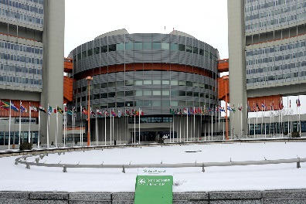
650 people travelled from 70 countries to the United Nations Offices in Vienna
Almost 650 people got onto planes, trains and automobiles to make the journey from all corners of the globe to participate in this truly global conference. Those travelling from the warmer climates of Indonesia, Ecuador and Ethiopia experienced quite a drop in temperature as they were welcomed to a cold and snowy Vienna.
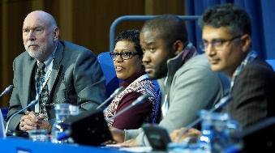
190 presenters gave their views across 40 sessions
Almost 200 people presented their ideas, views and projects which support persons with disabilities, across over 40 separate sessions spanning three conference rooms. In total there were 20 sessions for innovations, 8 forums discussing accessibility issues, 11 keynotes and 2 couch discussions.
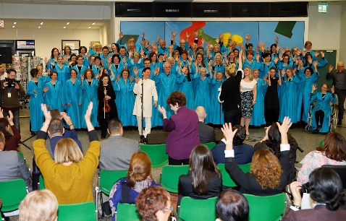
The Zero Project anthem was presented for the first time and the Zero Project Artwork was unveiled
The Longfield Choir gave the inaugural performance of the Zero Project anthem at a special event at the Rotunda of the UN Offices in Vienna. The anthem commemorates the 10th anniversary of the UN Convention on the Rights of Persons with Disabilities and was performed alongside the unveiling of the Zero Project artwork. The artwork, which celebrates the dignity of man, is a donation from the Essl Foundation and is on display in the rotunda, with many accessible features including a tactile board and relief images.
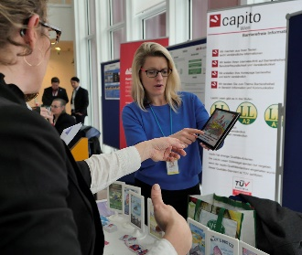
30 exciting projects exhibited their work
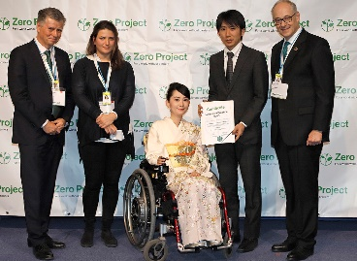
Throughout the duration of the conference over 30 projects from around the world exhibited their work to conference attendees, including apps to support navigation, read-aloud menus, tactile storybooks and audio libraries for the blind and visually impaired.
75 Awards were presented
75 Awardees of the Innovative Practices and Innovative Policies 2018 received their awards from Martin Essl, founder of the Essl Foundation during a ceremony in front of over 500 experts and leaders in disability from around the world.
123,000 people were reached via Facebook
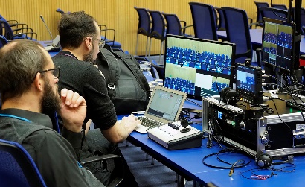
#ZeroCon18 was trending at number 2 in Austria at times during the conference. During the week from 18th to 24th February 123,000 people accessed content on the Zero Project Facebook page, with 42,990 views of videos during that time and the total followers passed 4,000 for the first time!

